 QRPGuys Digital AFP-FSK Transceiver III

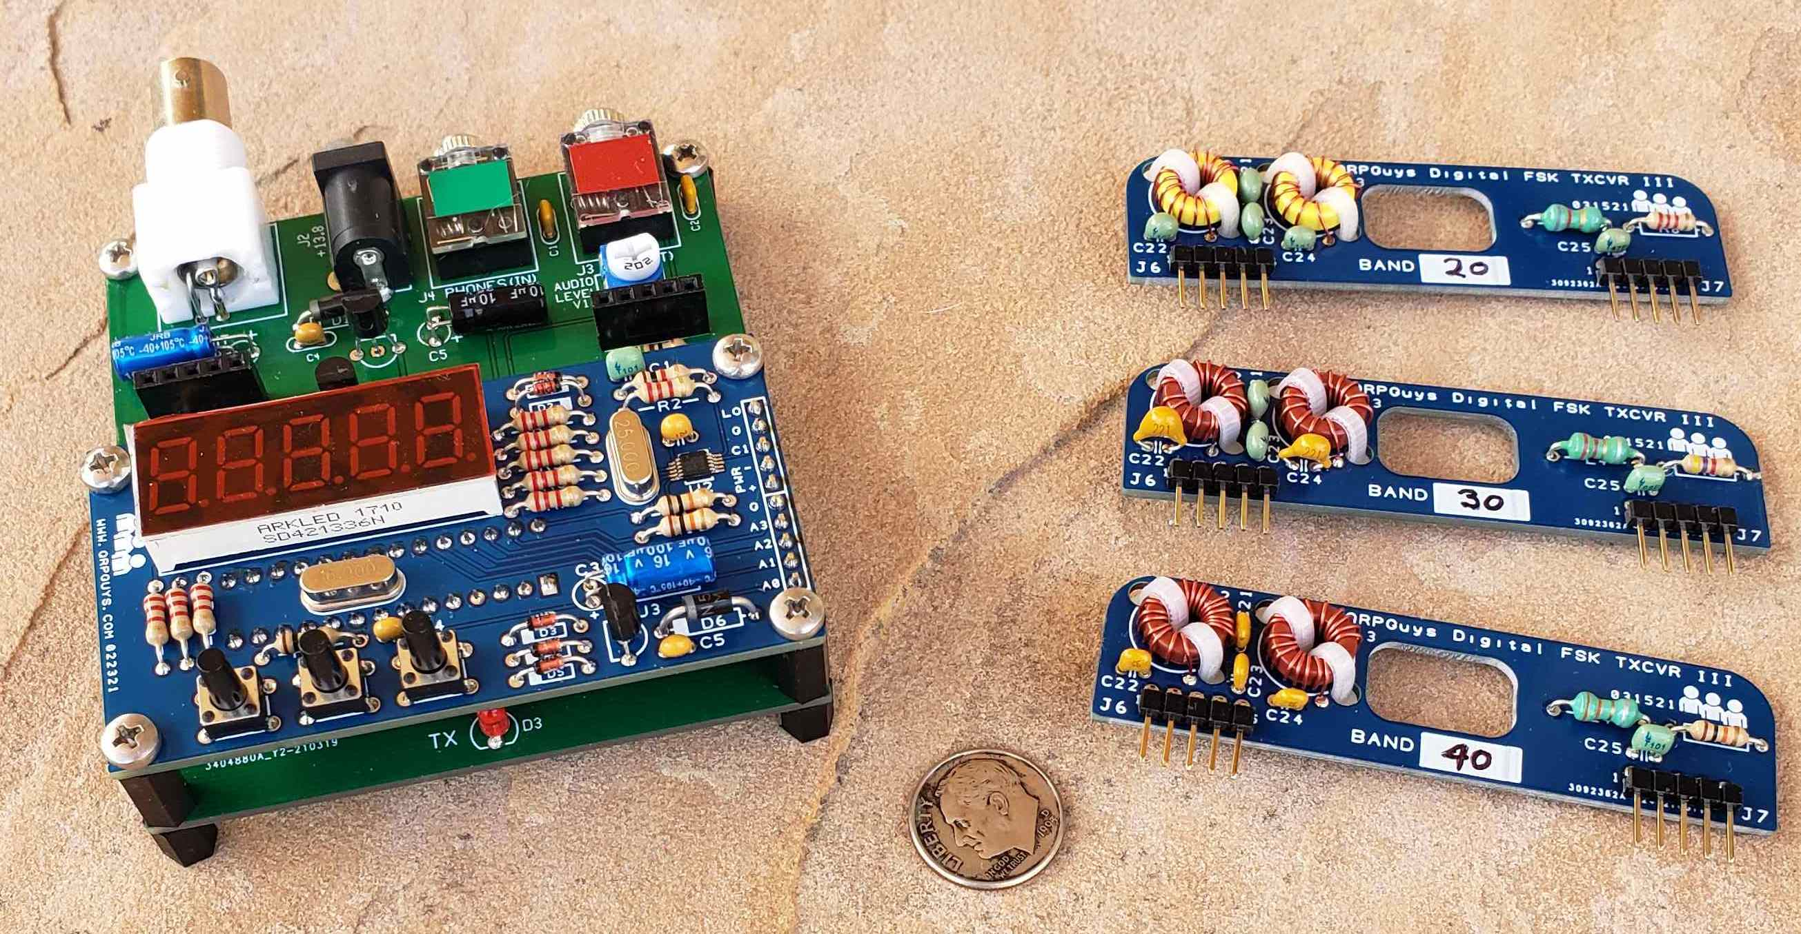

The QRPGuys Digital FSK Transceiver III with digital AFP-FSK VFO can operate on the ham bands 160m-6m and transmit all FSK modes generated by a sound card. The only exception is PSK31, which requires amplitude modulation and is not actually an FSK mode since it uses phase shift modulation.

Thanks to an innovative method developed by Kazuhisa “Kazu” Terasaki (AG6NS), audio tones generated by the sound card are applied to the VFO's processor. The audio frequency is determined by measuring the time between zero crossings and then added to the VFO base frequency to generate the required offset. Generating the transmit frequencies directly by the VFO eliminates the “Double Side Band” problem of designs using a simple mixer.

A Si5351/MS5351M clock chip is used as the VFO and produces square waves. This allows using an efficient MOSFET Class C power amplifier instead of a linear amplifier. Power output is at least 5 watts when powered by a 13.8V supply, (6m ~1 watt). Lower power output can be had simply by lowering the supply voltage. The Digital FSK Transceiver III can operate down to 8 volts.

Multiple bands are supported by using plug in band modules. A resistor on each module allows the VFO to automatically load the correct band frequencies. The kit includes parts for three bands (40/30/20m). Extra bare boards are available which can be populated for additional bands, 160m-6m, using parts obtained by the user.

The receiver is a simple Direct Conversion type using the popular SA612A mixer and LM386 audio amp. The output of the mixer is feed to the audio amp in a balanced fashion, which rejects common mode signals, like 60 cycle hum common to DC receivers. The receiver is quite sensitive and the gain boosting cap on the audio amp (C17) is likely not needed since the sound card does all the heavy lifting.

The MHz digits are displayed with a 1 kHz resolution. A display shift function allows viewing the 100 and 10 Hz decades for fine tuning. Tuning outside of the Ham bands is allowed. Caution: Transmit is not inhibited outside the ham bands, so be careful of that.
In an addendum, Steve has provided an option for a user installed TCXO on the VFO if desired, in place of the 25MHz crystal for added stability.
If you plan to tune outside the band, make sure your tuned to xx0.00 or xx5.00 before going beyond the band limits.

Parts list:
 | QTY | Value |  | QTY
 |  | Resistors |  |  | Semiconductors
 | 1 | 10 ohms [BRN-BLK-BLK-GLD] |  | 1 | 1N4148 | Sm. Glass
 | 1 | 51 ohms [GRN-BRN-BLK-GLD] |  | 1 | 1N4756A | Glass 47V 1W
 | 2 | 1K [BRN-BLK-RED-GLD] |  | 1 | 1N5817 | Plastic
 | 1 | 2.2K [RED-RED-RED-GLD] |  | 1 | Red LED | T-1
 | 2 | 2.7K [RED-VIO-RED-GLD] |  | 4 | BS170 | TO-92
 | 1 | 4.7K [YEL-VIO-RED-GLD] |  | 1 | 78L05 | TO-92
 | 3 | 10K [BRN-BLK-ORG-GLD] |  | 1 | 74AC02 | SO-14
 |  |  |  | 1 | LM386 | SO-8
 | 1 | 2 K 6mm Trimmer |  | 1 | SA612A or SA602A | SO-8
 |  | Capacitors
 | 1 | 33 pF [ 33 ] |  |  | Hardware
 | 2 | 47 pF [ 47 ] |  | 1 | FT50-43 | Black core
 | 2 | 68 pF [ 68 ] |  | 4 | T37-2 | Red core
 | 2 | 100 pF [ 101 ] |  | 2 | T37-6 | Yel core
 | 2 | 150 pF [ 151 ] |  | 1 | DC power jack | 2.1 x 5.5mm
 | 2 | 220 pF [ 221 ]
 | 3 | 330 pF [ 331 ] |  | 1 | BNC female jack | Right angle
 | 1 | 560pF [ 561 ] |  | 2 | 3.5 mm stereo jack | stereo
 | 1 | 680 pF [ 681 ] |  | 1 | 10 pin SIP female header | socket
 | 7 | 10 nF [ 103 ] |  | 2 | 5 pin SIP female header | socket
 | 8 | 100 nF [104 ] |  | 6 | 5 pin 90° header | SIP pins.
 | 4 | 10 ufd electrolytic |  | 1 | #26 mag wire | 8 feet
 | 1 | 100 ufd electrolytic |  | 1 | Main pcb
 |  |  |  | 3 | Band module pcbs
 |  | Molded Inductors |  | 12 | Sm. nylon zip ties
 | 1 | 1.2 uH RFC [BRN-RED-GLD-GLD] or [BRN-RED-GLD-SIL] |  | 6 | M3 x 5mm L. screw
 | 1 | 2.2 uH RFC [RED-RED-GLD-GLD] or [RED-RED-GOLD-SIL] |  | 2 | M3 x 20mm L. screw
 | 1 | 3.3 uH RFC [ORG-ORG-GLD-GLD] or [ORG-ORG-GLD-SIL] |  | 4 | M3 x 12mm L. nylon threaded spacer
 |  |  |  | 4 | M3 x 8mm L. nylon threaded spacer

First, familiarize yourself with the parts and check for all the components. If a part is missing, please contact us and we will send one. To request a part, please use qrpguys.parts@gmail.com.

Construction:

Parts placement diagram.

Print this out for handy reference.

Part locations are color coded to speed locating their placement. Resistor color coding is used to indicate the value for that location, using color for the zero multiplier. Therefore a 104 cap is colored Yellow. Note that resistors can share the same color as their zero multiplier is the same, but the value is different i.e. 1K and 4.7K, 10 ohms and 51 ohms.

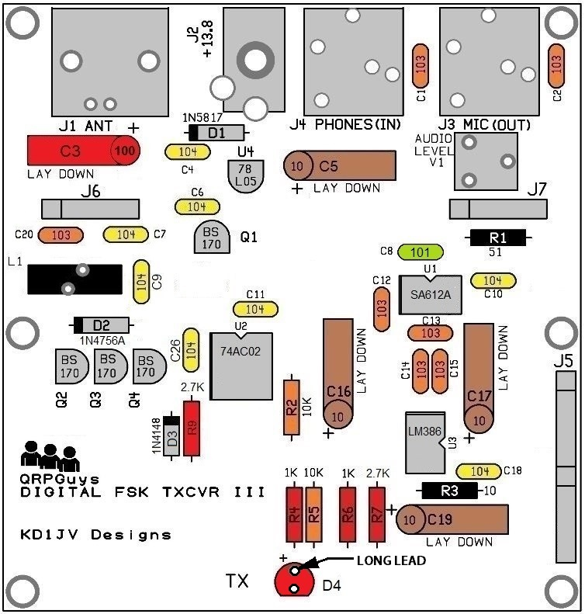
Assembly:

Start with the SMD ICs. It is easier to solder them in place before the other parts get in the way. It is helpful to use a small tip on the soldering iron and use very thin solder, since not much is needed. 0.015” is ideal, but 0.020” is acceptable and can also be used for general soldering. If all you have is 0.030, you will likely also need Solder Wick to remove shorts between leads.

Use tweezers to handle the part and hold it in place until the first lead is soldered.

- Lightly tin one corner pad.
- Locate pin 1 end of the IC and orientate it towards the notch on the part outline. Pin 1 can be marked with a dot or the manufactures logo, which is the case of the SA612A. There is also a noticeable bevel to the pin 1 side of the chip.

- Line up the leads with the pads and touch your iron to the lead over the tinned pad.
- Double check the lead alignment with the pads and correct if needed.
- Solder the opposite corner lead, then the rest.
- Be sure to apply the solder to the end of the IC lead, which helps insure some of it flows between the lead and pad. If it only sticks to the top of the lead, you won't have a reliable connection, but it could work for a while.

- [ ] U1 – SA612A or SA602A
- [ ] U2 – 74AC02
- [ ] U3 – LM386

Resistors:

- [ ] R1 – 51 ohms [GRN-BRN-BLK-GLD]
- [ ] R2,5 – 10K [BRN-BLK-ORG-GLD]
- [ ] R3 – 10 ohms [BRN-BLK-BLK-GLD]
- [ ] R4,6 – 1K [BRN-BLK-RED-GLD]
- [ ] R7,9 – 2.7K [RED-VIO-RED-GLD]

Diodes:

The transceiver will not operate if the diodes are installed incorrectly.

- [ ] D1 1N5817 – black plastic body, observe the polarity stripe
- [ ] D2 1N4756A – glass body, observe the polarity stripe
- [ ] D3 1N4148 – sm. glass body, observe the polarity stripe

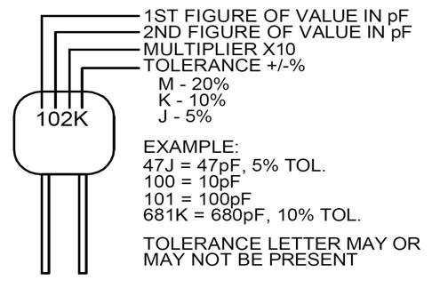
Note: When reading the capacitor values, do not confuse the manufacturing codes with the component value. If it looks strange, it may be a manufacturing code, look on the other side of the component.

Capacitors: (by ascending value )

- [ ] C8 – 100 pF [101]
- [ ] C1, C2, C12, C13, C14, C15, C20 – 10 nF [103]
- [ ] C4, C6, C7, C9, C10, C11, C18, C26 – 100 nF [104]
- [ ] C5, C16, C17, C19 – 10 uF elecrtolytic [long lead is plus] Lay down on board.
- [ ] C3 – 100 uF electrolytic [long lead is plus] Lay down on board.

Make sure you have C3 installed with the correct polarity. If it's in backwards, it can burn out! (and smells awful)

Misc:

- [ ] U4 – 78L05
- [ ] Q1, Q2, Q3, Q4 – BS170
- [ ] D4 - LED – [long lead is plus]
- [ ] VR1 – 2K Trimmer pot.

L1:

- [ ] 13 turns #26 magnet wire (12”) on FT50-43 core (black) – Be sure to tin the wire leads before inserting into board. Pull the core snug to the board with the wire leads, but make sure you don't go past the tinned area. Wind as shown below and the leads will align with the offset holes in the pcb.
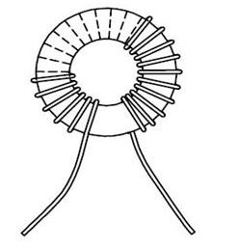
Hardware:

- [ ] J3, J4 – 3.5mm Jacks.
- [ ] J2 – DC power jack.
- [ ] J1 – BNC connector.
- [ ] J5 – 10 pin SIP header socket. Make sure you get this flush and square to the board before soldering more then one pin.
- [ ] J6, J7 – 5 pin SIP header sockets. Solder a single pin and check for squareness.

Band Modules: 6m component details in the addendum
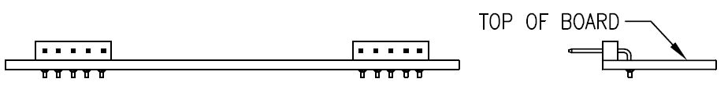
The table below lists the values for the various bands. Values for the supplied bands are listed to the left of the red line.

- Install the right angle pins first as shown above.
- Be sure you mark the module with the band using a permanent marker before assembly. Sort the parts for each band separately. Incorrectly placed parts are very difficult to correct.
- Install the capacitors, resistors, and inductors as described in the table below.
- Use 12” 26AWG magnet wire when winding the cores, make sure you wind the wire
- snug to the sides of the core and double check the number of turns. A turn is each time the wire passes through the center. A core with a extra turn or is loosely wound will reduce power output. If you wind as shown below, the leads will align with the pcb holes.
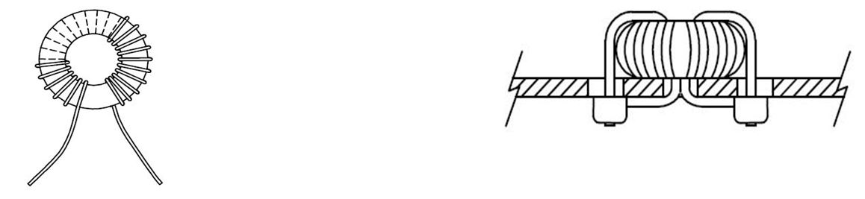
- The magnet wire insulation can be burned off with a soldering iron. Turn the temp up as high as it will go and make a little blob of solder on the tip of the iron. Tin the wire before mounting the core, as the solder pad will suck away too much heat to melt through the insulation and make a reliable connection. The core should be mounted snug to the board, but make sure you don't pull the wire through the hole past your tinned area.
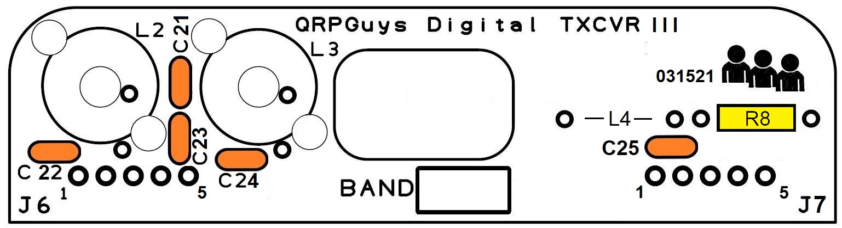
The spacing of the turns and how tightly the turns are wound on the L3 toroid will affect power output. Therefore the spacing of these turns may need to be adjusted for optimum power output or efficiency. Do no zip tie the core to the board until you test the module for power output and transmit current.
Location | 40M | 30M | 20M |  | 160M | 80M | 60M | 17M | 15M | 12M | 10M
R8 | 10K | 4.7K | 2.2K |  | 390Ω | 47K | 15K | 22K | 0Ω JUMPER | 750Ω | 33K
C21 | 68p [68] | 47p [40] | 33p [33] |  | 220p [221] | 150p [151] | 68p [68] | 22p [22] | 22p [22] | 15p [15] | 15p [15]
C22,24 | 330p [331] | 220p [221] | 150p [151] |  | 1500pF [152] | 680p [681] | 330p [331] | 150p [151]  No C24 | 100p [101] | 22p [22]  No C24 | 22p [22]  No C24
C23 | 680p [681] | 560p [561] | 330p [331] |  | 2x 1500pF [152]  In Parallel | 2x 680p [681]  In Parallel | 680p [681] | 330p [331] | 220p [221] | 150p[151] | 150p[151]
C25 | 100p [101] | 68p [68] | 47p [47] |  | 220p [221] | 100p [101] | 100p [101] | 33p [33] | 68p [68] | 47p [47] | 47p [47]
L2 | 20T Red  T37-2 | 16T Red  T37-2 | 18T Yel  T37-6 |  | 22T Blue  T37-1 | 26T Red  T37-2 | 23T Red  T37-2 | 14T Yel  T37-6 | 14T Yel  T37-6 | 14T Yel T37-6 | 12T Yel T37-6
L3 | 18T Red  T37-2 | 13T Red  T37-2 | 14T Yel  T37-6 |  | 23T Blue  T37-1 | 25T Red  T37-2 | 22T Red  T37-2 | 11T Yel  T37-6 | 10T Yel  T37-6 | 11T Yel  T37-6 | 10T Yel  T37-6
L4 | 3.3 uH | 2.2 uH | 1.2 uH |  | 39 uH | 18 uH | 10 uH | 1.2 uH | 0.68 uH | 0.68 uH | 0.68 uH

For those that want to build modules for other bands, and may not have the parts, we buy our toroids from <https://www.kitsandparts.com/>. Diz also carries the solder heat stripping 26AWG magnet wire. We use Mouser for NP0/C0G capacitors. Resistors and molded chokes are inexpensively obtained from Mouser or https://www.taydaelectronics.com/. The only other item needed are the 2.54mm Pitch Right Angle Male Single Row Pin Header Strips. You want to buy the style that the insulator is on the long leg. We buy ours from eBay, like item #172288868464 in 40 pin strips.

If desired, the band modules for 12m and 10m can be combined. However the builder must choose which default start-up band they want by the R8 choice, and tune to the other band manually.

The main board and band modules are now complete. You can proceed to the VFO portion of this manual on p. 13. You will return to here to do the testing of your main board with the VFO attached.

Testing:

Before you do anything else, inspect your work. 100 out of 100 times, the reason a kit does not work first time is due to soldering issues. Best to look for and fix any iffy connections now.
- Grounds take more heat then other connections, so pay attention to these locations. Sometimes solder can stick to around the bottom of the lead, but not actually touch the pad. Check to see if there is solder visible around the lead from the top side of the board. If not, solder may not have flown into the hole.
- Use a magnifying glass to check for shorts between the SMT IC leads.

Everything look good? Time for the smoke test.

When powering up a board for the first time, it's a good idea to use a supply which can only deliver a limited amount of current. If you use the 35A supply for your “Big Rig”, better stand back when you throw the switch. :)

A fresh 9V radio battery will power the board for a while and even produce a couple of watts of output power. A bank of AAA batteries will also do the trick. Or just used a fused power cord with no more then a 1A fuse in line.

- The audio output can drive a set headphones, so plug a pair into the audio output jack (J3 labeled MIC-OUT). Turn the audio level control fully clockwise for maximum volume. Since a 10 ufd cap is used to couple the audio output, any voice will sound muffled or tinny.
- Pick a band sure to have activity (40M is a good bet any time of day or season) and plug in that band module.
- Attach your antenna.
- Connect up the supply and turn it on. For 1 sec. the display will read [ F8** ]. The ** is the revision of the firmware. Following that, for 1 sec. will be the selected band module [ bn ** ], and then the FT8 operating frequency, typically [ **74.0 ].
- You should now hear signals in the headphones. Since this is a Direct Conversion receiver, all modes including AM can be received, so you can tune up and down the band if you like.

Now that the receiver operation has been verified, time to hook it up to your computer.

- Start the WSJT-x program
- Connect up the audio cables to the appropriate jacks
- Turn power back on, (unless you didn't bother to turn it off first)
- See if signals start to be decoded.

Transmitter testing:

- Disconnect your antenna and connect a QRP power meter and dummy load to the antenna jack.
- Activate the TUNE mode in the program.
- Adjust the Pwr slider until the Transmit LED comes on, then run it to the top.
- You should see power out on the meter. How much depends on supply voltage.
- Exit tune mode.

Everything work as it should? Great. Reconnect your antenna, wait for a CQ to show up and double-click on it (be quick) and sit back.

Module Optimization:

L3 tweaking:
In general, the more evenly spaced the turns on L3 are, the greater the power output. In some cases, this can result in much more the 5 watts output with a 13.8 V supply and excessive transmit current, which will lead to excessive heating of the PA BS170’s.
Grounding the (FORCE TX) pad on the main board or “A0” terminal on the VFO board will force transmit, allowing you to measure power output and transmit current without having to connect the board to a computer.
With a 13.8V supply, power output should be about 5 watts with about 600 ma of current draw. High frequency bands will draw a little bit more current, but should stay below 700 ma.
If you have excess power, moving a few turns on L3 closer together will reduce the power.
If your power output is low, space the turns father apart. If it’s way low, you likely have the wrong number of turns on the cores.

Calibration:

Variations in crystals and PLL sensitivity will vary VFO frequency will likely be off by a few hundred Hz and should be calibrated. It's nice to have the output frequency match the dial. If you don't calibrate, you might have to tune up or down a bit to better center the FT8 (or other mode) signals in the waterfall or you could be missing out on some stations.

Calibration can be done by several methods.
- Use a frequency counter if you got one.
- Use your big rig if it is reasonably accurate (and it probably is) or
- Zero beat a SWBC station operating in or near one the bands. There are usually several on the high end of 40M in the evening.

To enter calibration mode:

- Allow the transceiver warm up for 5 minutes
- Click and hold closed the Function/menu switch for ~12 seconds until [CAL] appears. Release the switch and the display will change to [C 74.0] assuming the you haven't changed the frequency before.
- The VFO signal will appear on the CO output.
- Use the tuning switches to adjust the output of the VFO to exactly match the dial frequency. If you have say the 40M band selected it would be 7.074,000 MHz.
- If using a frequency counter, you will need to connect it to the end of the resistor divider going to the Si chip.

Using a receiver:

- set the mode to CW and tune to the desired VFO frequency.
  - Depending on which side band the receiver uses for CW, you may not hear the beat note. Determine if the VFO frequency is above or below the desired frequency.
  - Reset the receiver to the desired frequency and use the VFO tune up or tune down switches until you hear the proper CW tone. If you can patch the audio from your receiver to the computer, a good way to do this is to use the waterfall in the WSJT-x program. You will need to know what the CW side tone frequency normally is when tuned to a given frequency.

Using a SWBC station.

- The audio output of the Digital FSK Transceiver v. III board will drive headphones, so plug a set into the audio output jack and turn the Audio level pot all the way up.

  - SWBC stations are on exact 5 kHz steps. You can tune outside the Ham bands with VFO, in which case the tuning will become 5 kHz steps. Make sure you have “zeroed out” the kHz, 100 Hz and 10 Hz decades before going out of band. Since the power up frequency is xx.074000 MHz, advance the frequency to xx.075000 and use the 5 kHz tuning rate to step outside the band and find a SWBC station to zero beat.
  - Once you found a station, there will be a beat note or a wobble to the audio. Tune until the tone and wobble goes away and the audio is clear sounding.

- When done, click the Function/Menu switch to store the calibration number.

Calibration technique to 10MHz WWV

If you can hear 10.000MHz WWV in your location there is an easy calibration technique. Install the 30m band module and see if you can hear WWV if you have manually tuned the VFO to 10.00MHz and can hear the signal with earbuds attached to J3.

If so:

- For the most accurate calibration let the transceiver warm up for 5-10minutes.
- Remove the earbuds and connect the transceiver to your computer.
- Start up the WSJT-x software and set to 30m.
- Install the 30m module and manually set the VFO to 9.999MHz.
- Hold S1 button down until you enter the “CAL” mode. About 13-14 sec.
- Hold down S2 or S3 to move the calibration in the direction to match the picture below.
- When properly calibrated, you should see a sharp line at 1000Hz with tones either side of the center frequency, as shown below.
- Press the “menu” once more to store the calibration number.

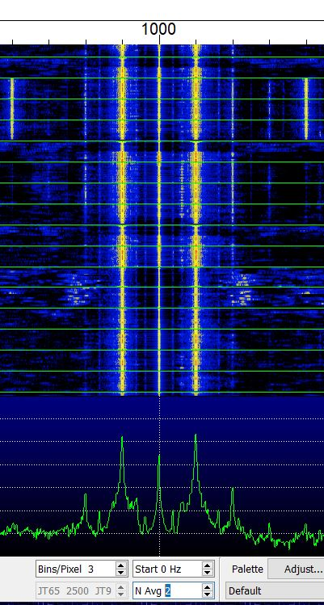

This same technique is used on any signal you can receive and know the exact frequency.

Operation:

If your new to FT8, the first thing you need to do is download and install the WSJT-x software to your computer. https://physics.princeton.edu/pulsar/k1jt/wsjtx.html

- HINT – the WSJT-x software requires the sound card to sample at 48000. Most sound cards default at 44000, so you have to go into the setting menus to change this. Instructions are in the WSJT-x operating guide. If you fail to do this, nothing will decode and you will go crazy trying to figure out why, at least I did, HI. Also, if you are using a laptop which has a built in mic, you need to disable it or noises in the room will disrupt decoding. How do I know this? Guess.
- Before you can start transmitting, you need to do some set up of the program.
- Go to [settings] in the [file] menu. Enter you call sign and grid location. You can alternately use country or state.

- Be sure to check the “double-click on call sets Tx enable” and “disable Tx after sending 73” boxes. “Calling CQ forces Call 1st” is optional but recommended.
- On the main page, you'll want to check the “Hold Tx Freq” and “Auto Seq”
- Then read the help files and DX operating tips guide.

Digital FSK Transceiver v. III board connections:

- Plug in the desired Band Module card
- Using 3.5mm audio cables (you can get these at the dollar store, for a dollar!)
  - Connect J4 (PHONES IN) to the SPEAKER output of the PC/laptop.
  - Connect J3 (MIC OUT) to the AUX or Mic input of the PC/Laptop. If you have a choice, AUX in is preferred.
- Attach your antenna
- Plug in the power supply. There is no on/off switch on the board, so that is done at the supply if it has one. A regulated supply at the desired voltage is recommended.
- After a few seconds you should start to see messages appear in the band activity window.
- If the audio level meter starts flashing red, you need to turn down the input level. The quickest way to do this is with the VR1 audio level control on the board. (keep an appropriate screw driver handy) or with the computers' audio input level control, but to do this you have to go through several menus and is a pain, but you will probably need to set this at least once, especially if using the MIC input.
- Locate a clear frequency on the waterfall and set your transmit frequency there. (SHIFT+left click)
- Use the [TUNE] button to set the audio level to the v. III board. Adjust the [Pwr] slider at the right side edge of the screen until the red transmit LED comes on and keep going. Over driving the input to the VFO processor eliminates any measurement “jitter”.
- Now your all set to answer a CQ or send a CQ. Happy operating!

- Remember when changing bands, turn off the rig and restart the rig to read the band sensing resistor.

- It's a good idea to have a small screw driver handy to adjust the audio level to keep the audio level in the “green” zone on the audio level indicator. The audio level will likely need to be adjusted depending on band, band conditions and amount of activity.

Troubleshooting:

What can go wrong?
Not much really.

As mentioned earlier, 100 out of 100 problems are tracked back to soldering issues. Everyone seems to be able to get the correct parts in the correct places. But it pays to check. Mixing up capacitor values is the most likely mistake, since the numbering on the caps is pretty small and hard to read. Some of them have similar numbers like the 68p and 681 pf. Mixing up the 100 nF and 10 nF caps is unlikely to be noticed.

A close visual inspection of the solder connections with a magnifier will usually identify problem areas.

One common soldering issue is the magnet wire on the cores. Verify continuity across them with an ohm meter.

Laying a piece of Solder Wick across the leads of the SMT chip ICs and touching with your iron ensures all the leads are soldered and removes any hidden shorts.

No luck with the visual inspection?

Try to identify the problem area before taking the shot gun approach of re-soldering everything. A DMM is can be useful to check a few critical voltages, like are you even getting power to the circuits? Some typical voltages are noted on the schematic.

But for nitty-griddy troubleshooting you really need a signal generator and Oscilloscope and if you have those, you probably don't need any more instruction.

A full 5W output can be obtained with 13.8V supply. Low power output is typically due to an extra turn on the toroids. Remember, count the number of times the wire passed through the center of the core. Loosely wound cores can also cause low power output. Double check the location and value of the caps in the filter.

Board tracks. Most “floating” pads are connected to the ground plane, not shown for clarity.
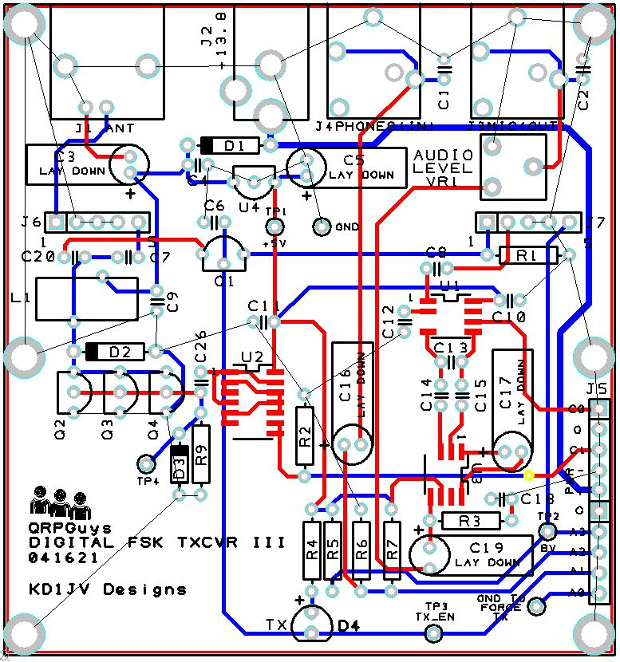

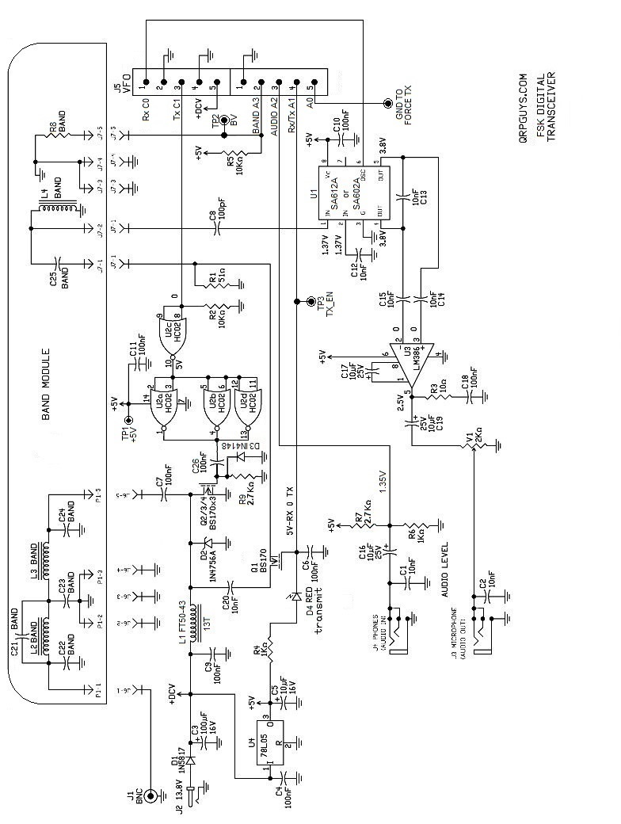

Si5351A VFO for the AFP-FSK Transceiver
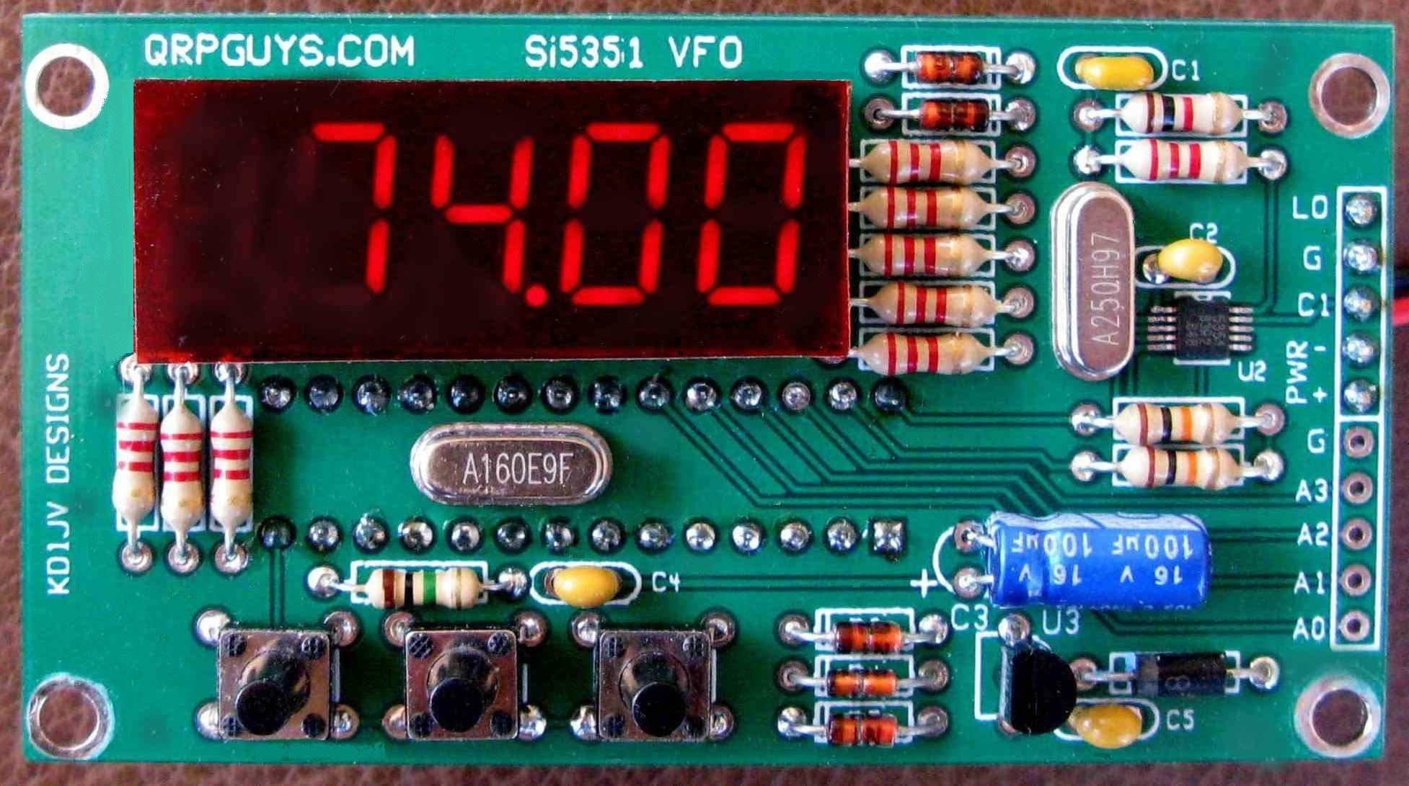

This Si5351A/MS5351M VFO was specifically designed to complement the QRPGuys Digital AFP-FSK Transceiver for 80m-6m. The default frequencies are FT8 frequencies. The VFO enables the transceivers to operate in other parts of the band so that other modes can be used or monitored.

Because this VFO is designed to be used with a Direct Conversion transceiver, the VFO output is at the display frequency with no offset.

The firmware has been dramatically edited from our original code by Kazuhisa “Kazu” Terasaki (AG6NS) and Steve Weber (KD1JV) for this version of the AFP-FSK VFO. It is written with Arduino IDE and is open source code and is licensed under the GNU, allowing for the user to modify the sketch to add functions.

First, familiarize yourself with the parts and check for all the components. If a part is missing, please contact us at <qrpguys.parts@gmail.com> and we will send you one.

Assembly
Parts list:

 | Quantity | Value |  |  | Quantity | Value
 |  | Capacitors |  |  | 1 | 78L05 | TO-92
 | 1 | 100 pF [101] |  |  | 1 | Si5351A or MS5351M | MSOP10  Pre-Installed
 | 3 | 100 nF [104] |  |  | 1 | MEGA328 | 28 pin DIP
 | 1 | 100 uF electrolytic |  |  | 1 | 5 digit | 7 segment LED display
 |  |  |  |  | 1 | 16.00 MHz | HU-49US
 |  | Diodes |  |  | 1 | 25.00 MHz | HU-49US
 | 5 | 1N4148 glass body
 | 1 | 1N5817 black plastic body |  |  | 3 | 11mm | TACT switch
 |  |  |  |  | 1 | 28 pin DIP | IC socket
 |  | Resistors
 | 1 | 1 K [BRN/BLK/RED/GLD] |  |  | 1 | PCB | Circuit board
 | 9  1  2 | 2.2 K [RED/RED/RED/GLD]  1 M [BRN/BLK/GRN/GLD]  10 K [BRN/BLK/ORG/GLD] |  |  | 1  1 | Misc. | Red acetate filter, 3/4”x2”  SIP 10 position pin str
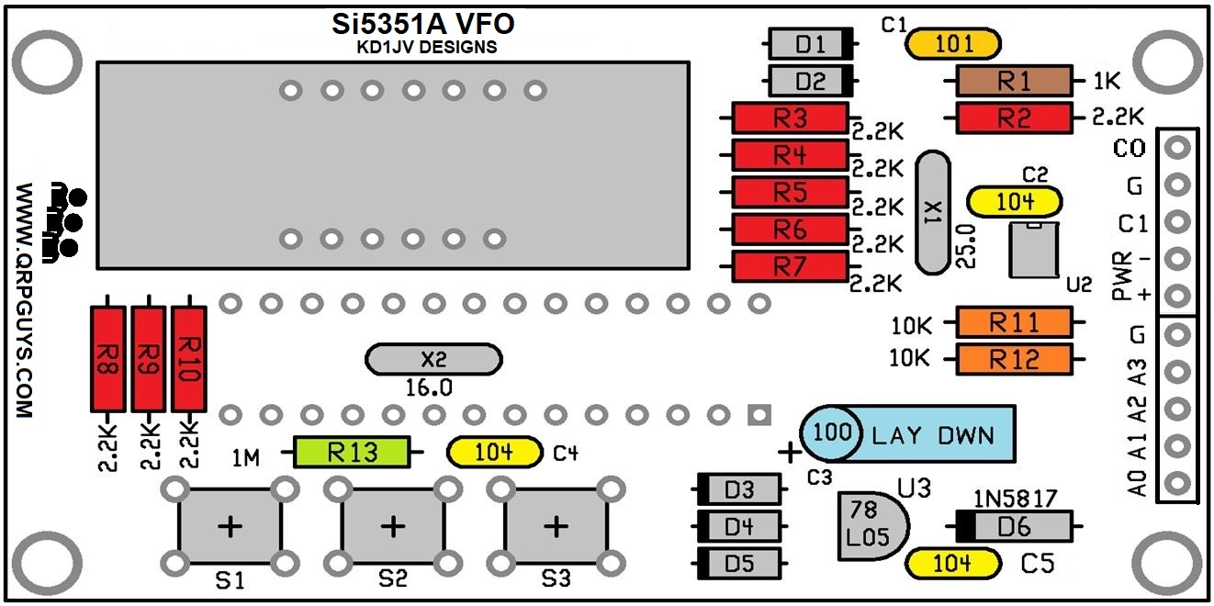
Board v. 022321, note placement of C2

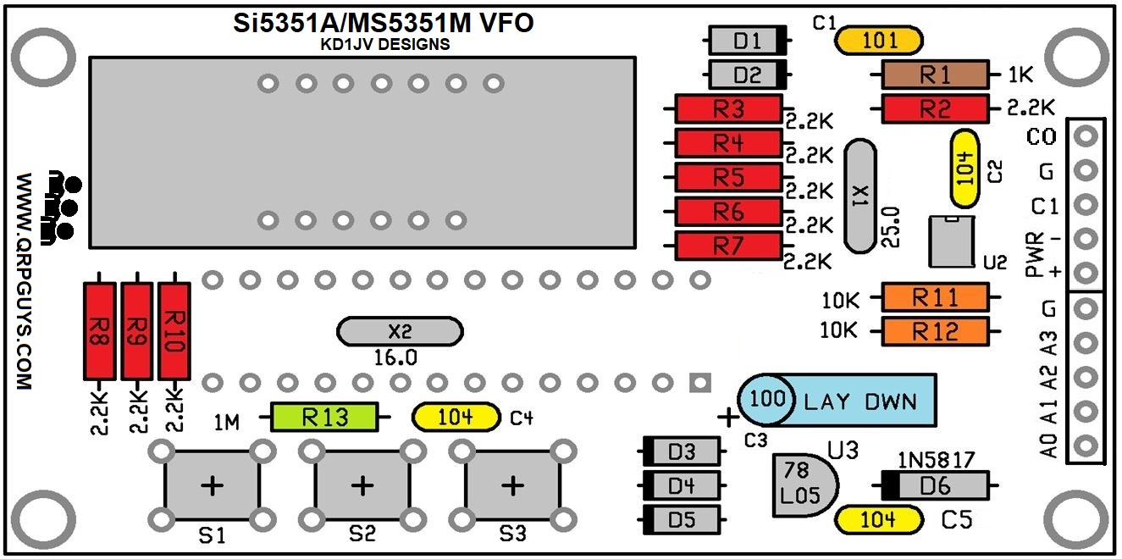
Board v. 052721 and later, note placement of C2

The VFO will not operate if the diodes are installed incorrectly.

[ ] D1 to D5 (5 places) 1N4148 diode – glass body. Note banded end, match with the silkscreen outline.

[ ] D6 (1 place) 1N5817 diode – black plastic body. Note banded end, match with the silkscreen outline.

[ ] R1 – 1 K resistor [Brown-Black-Red-Gold]
[ ] R2 to R10 (9 places) 2.2 K resistor [Red-Red-Red-Gold]
[ ] R11, R12 (2 places) 10 K resistor [Brown-Black-Orange-Gold]
[ ] R13 (1 place) 1 Meg resistor [Brown-Black-Green-Gold]

[ ] X1- 25.00 MHz crystal
[ ] X2 – 16.00 MHz crystal – Make sure the leads are soldered as the DIP socket will cover these pads and will difficult to fix if there is a soldering issue there.

[ ] C1 (1 place) 100 pF [101]
[ ] C2, C4, C5 (3 places) 100 nF (0.1 uF) [104]
[ ] C3 – 100 uF electrolytic. Lay this part down flat to board. Long lead is + .

[ ] 28 pin DIP socket. This gets installed on the bottom of the board. Match notch on socket with notch on board. Before soldering more than one (1) lead, make sure all of them are sticking out of pads and the socket is set flat onto the board. If a lead gets folded under the socket as you insert it, fixing it will be difficult once more than one lead is soldered.

[ ] Display – this can only go in one way.
[ ] S1, S2, S3 – TACT switches.
[ ] U3 – 78L05, observe the silkscreen outline
[ ] Install the 10 pin SIPs at J5 on the back side of the pcb.
[ ] U1 – ATMEGA328P in socket. Match notch on end of chip with notch on socket.

This completes assembly of the board.

Preliminary testing:

- Before applying power, do a double check of your soldering, making sure you didn't miss any.

- Temporarily tack a couple of clipped resistor leads to the PWR + & -, and connect 9 to 12 volts to the power terminals.

- The display will show F8 X.X (X.X being the revision of the firmware), followed by a random frequency, because the VFO is not connected to the transceiver. When connected it will read the resistor on the band module and display the FT8 frequency for that given band that is plugged in.

The VFO is now ready to use.

Mounting the VFO assembly to the main board:

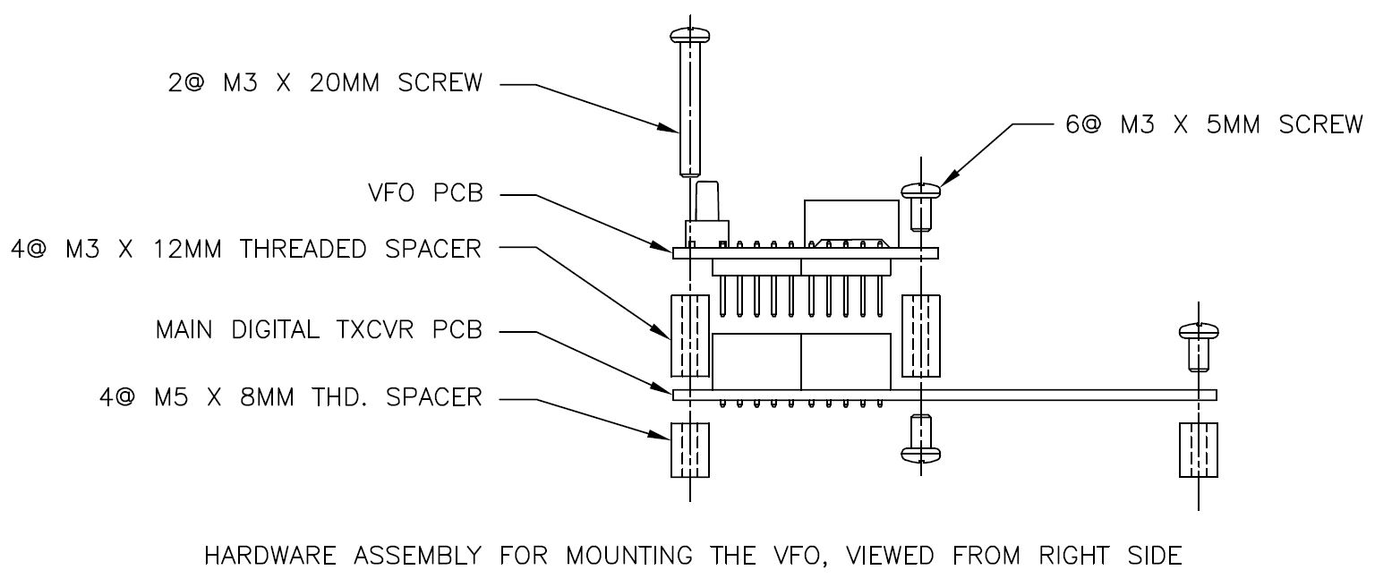

- Assemble the hardware to the VFO board first, two 20mm L. screws to the front and two 5mm L. screws to the rear retained by the four 12mm L. threaded spacers on the bottom.
- Plug the VFO assembly into the main board and secure with two 8mm L. threaded spacers in front and two M3 x 5mm screws up from the bottom, in the middle.
- Finally two M3 x 5mm screws and two 8mm threaded spacers to the rear.

Once the AFP-FSK VFO has been installed to the main board, you can return to the top of p. 7 and proceed with testing.

AFP-FSK VFO Operation:

- Default is MHz decades displayed with 1 kHz resolution. (decimal point at 2nd digit)
- Display shift (dS) shows frequency to 10 Hz resolution, MHz digits implied. (decimal point at 3rd digit)
- Leading zero suppressed in both display modes.

Tuning rates:
- 100kHz, 10 kHz, 5 kHz and 1 kHz rates when MHz digits displayed.
- Selected decade digit blinks. 1 kHz digit blinks twice when 5 kHz rate is selected.
- 100 kHz, 10 kHz, 5 kHz, 1 kHz, 100 Hz and 10 Hz rates in kHz digits only display.
The VFO is controlled by three push buttons.

- Menu.
- Tune down.
- Tune up.

MENU:

Since there is band sensing on the modules the manual band selection has been disabled. The program will default to the the FT8 frequency on each band as the sensing resistor queues the VFO at startup. Remember when changing bands, restart the rig to read the band sensing resistor.

Menu button 1/2 sec. push, change decade digit for tuning rate.
Menu button 2 sec. push, 'dS', display shift
Menu button ~12 sec. push, 'CAL', calibration
Menu button 15 sec. push, 'rES', clear eeprom stored information (frequency calibration value).

Calibration:
- Calibration is covered when you return to the testing and setup starting on p.7.

Tune Up and Tune Down:
The frequency is advanced or decremented by the selected tuning rate each time the switch is clicked.

Notes:
____________________________________________________________________________________________________________________________________________________________________________________________________________________________________________________________________________________________________________________________________________________________________________________________________________________________________________________________________________________________________________________________________________________

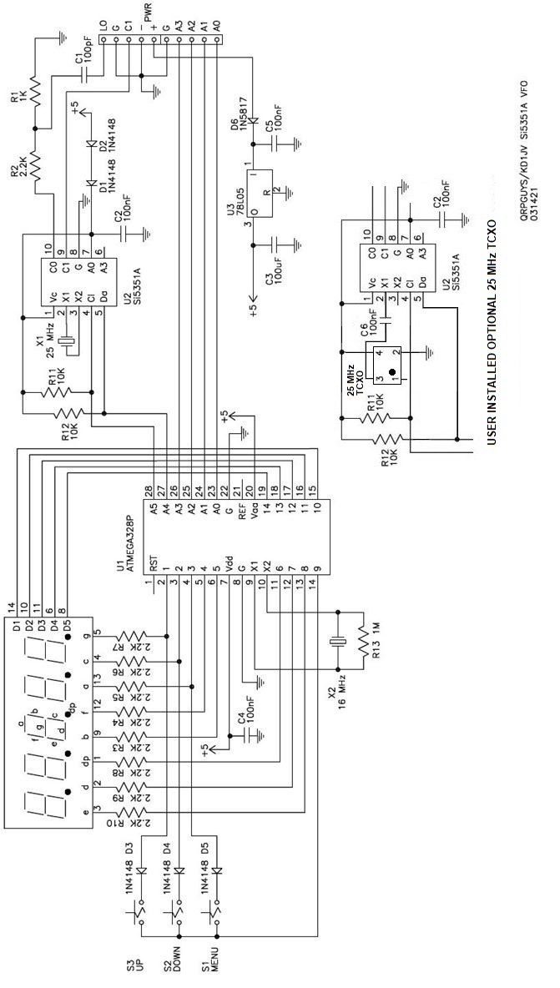

Addenda:

25.000 MHz TCXO Modification

The current crystal controlled VFO design has excellent stability after a few minutes warm up. For the ultimate in stability Steve provided for the installation of a commonly available 5.0mm x 3.2mm SMT 25.000 MHz TCXO on the solder side of the VFO board. It can be added at any time. We will not be supplying the TCXO, but it is inexpensive and available from Mouser as part# 520-TXO-5032-25.0T or Digikey# XC2070CT-ND. An additional coupling capacitor, C6, 100nF 50VDC MLCC will also be needed, and the 25.000MHz (X1) crystal is removed. This modification still requires the calibration step described in the manual. However if line 36 of the .ino is set to (#define SI5351BX_XTAL 25000000) and the Atmega328P is re-flashed, it will be extremely close. Boards v. 052721 and later will have the tcxo user option. Again you will need to supply your own TCXO, coupling capacitor, remove X1, the 25 MHz crystal, and have the ability to install the SMT TCXO. A manual soldering iron is recommended. Use caution if the hot air method of soldering is used. The MSOP10 SMT device is very close on the opposite side of the board.
If you substitute a different tcxo be sure to get one with <3ppm tolerance.

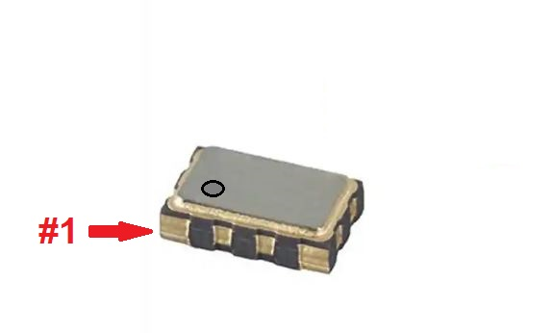
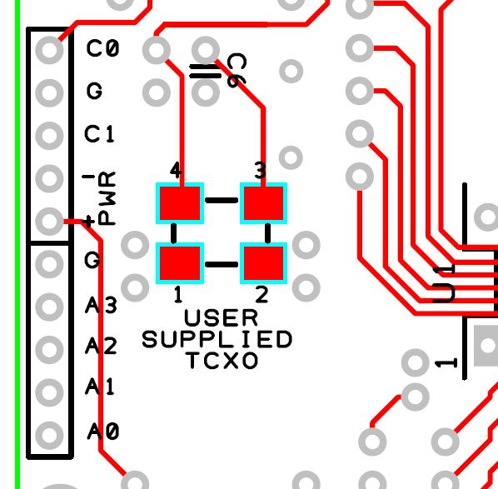
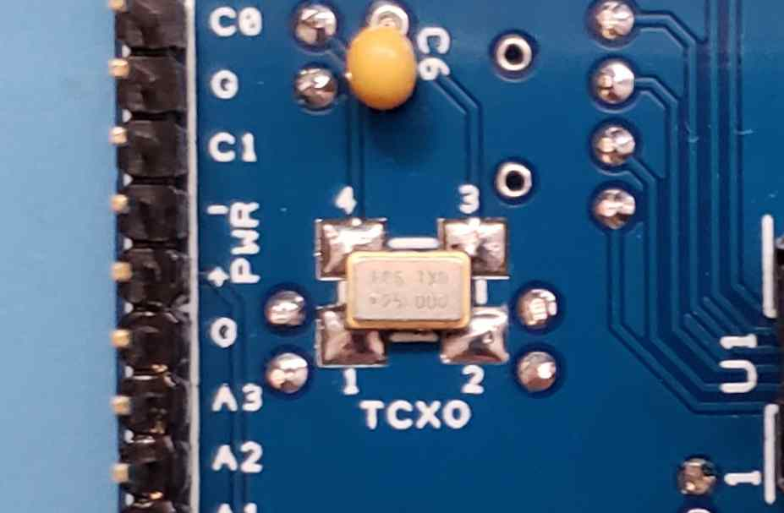

6 meter module details

The table on the left describes the 6 meter module component requirements. Power output is approximately 1 watt and the receiver sensitivity is slightly reduced.
Location | 6M
R8 | 200K
C21 | 10p [10]
C22,24 | 22p [22]
C23 | 68p [68]
C25 | 22p [22]
L2 | 9T Yellow  T37-6, 24awg
L3 | 8T Yellow  T37-6, 24awg
L4 | .22 uH molded  inductor or 6T  #24AWG Ø.25 I.D. close wound

Mount L2 vertically on the front of the module and L3 vertically on the rear of the module, to reduce coupling with the board traces and each other. Use 24awg wire evenly spaced for mechanical stability. Mount the capacitors, resistor, and L4 on the front side.
The AFP-FSK kits supplied after 09/29/22 will have the 6m option programmed into the vfo. If you plug in the 6m module with the 200K resistor installed at R8 and power up, it will come up with the 6m FT8 frequency. Earlier vfo's will need to have an Atmega328P reprogrammed using the Arduino sketch on the main page. We will not be supplying updated Atmega328P chips for older kits due to the global shortage of mpu's. You will need to reprogram an Atmega328P yourself using the Arduino sketch on the main page in a .zip file dated 09/29/22 or later.



